NUnit ASSIGNMENT -1

**Task 1:**

Create WEBAPI application named “WebApiNunit”

* Open Visual studio 🡪New Project🡪select Visual C#->Web🡪Asp.Net Web Application(.NET Framework)
* Named as “WebApiNunit” then Click Ok.

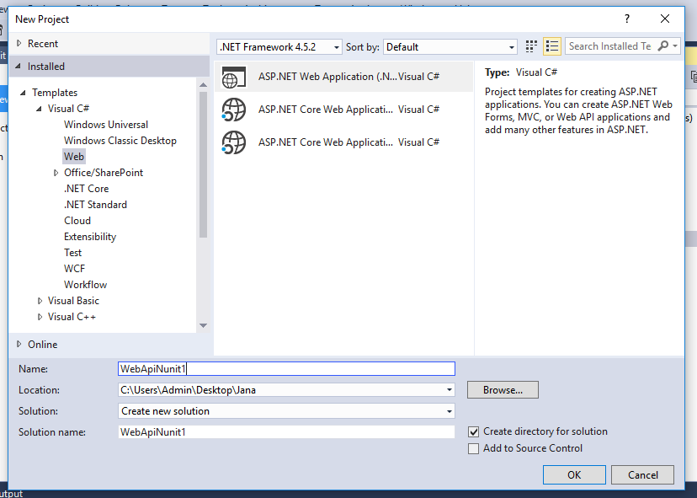

* New window will open select Web API ,by default mvc and web api will select in code reference items
* Select the **Add unit tests** option. The unit test project is automatically named **WebApiNunit.Tests**

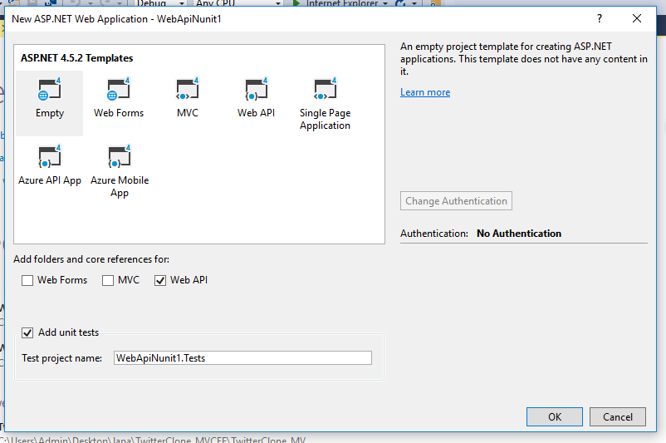

* After creating application it will create 2 project WebAPI and WebAPI test project.

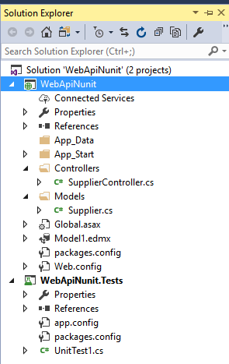

* In your WebApiNunit project, add a class file to the **Models** folder named **Supplier.cs** and write code as below

using System;

using System.Collections.Generic;

using System.Linq;

using System.Web;

namespace WebApiNunit.Models

{

public class Supplier

{

public string SuplNo { get; set; }

public string SuplName { get; set; }

public string SuplAddr { get; set; }

public Item Items { get; set; }

public POMASTER Pomasters { get; set; }

}

public class Item

{

public string ItCode { get; set; }

public string ItDesc { get; set; }

public string money { get; set; }

public ICollection<Supplier> Suppliers { get; set; }

}

public class POMASTER

{

public string PoNo { get; set; }

public DateTime PoDate { get; set; }

public string SuplNo { get; set; }

}

public class PODETAIL

{

public string PoNo { get; set; }

public string ItCode { get; set; }

public int Qty { get; set; }

}

}

* Right-click the Controllers folder and select **Add** and **New Scaffolded Item**. Select **Web API 2 Controller - Empty**.
* Set the Controller name as SupplierController.

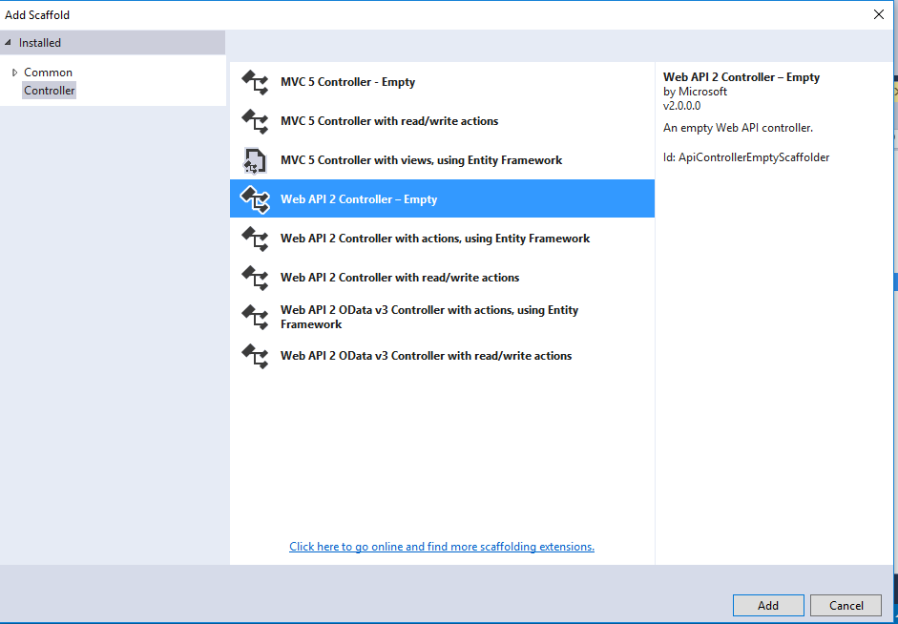

* Add ADO.net connection to map the Supplier table to perform operation.
* Right click of WebAPI service project –>Add new item🡪Inside Data🡪ADO.NET Entity model
* Select Database and select table and click ok button

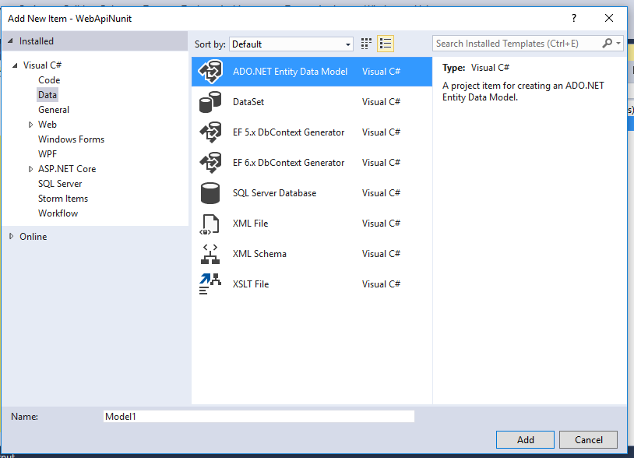

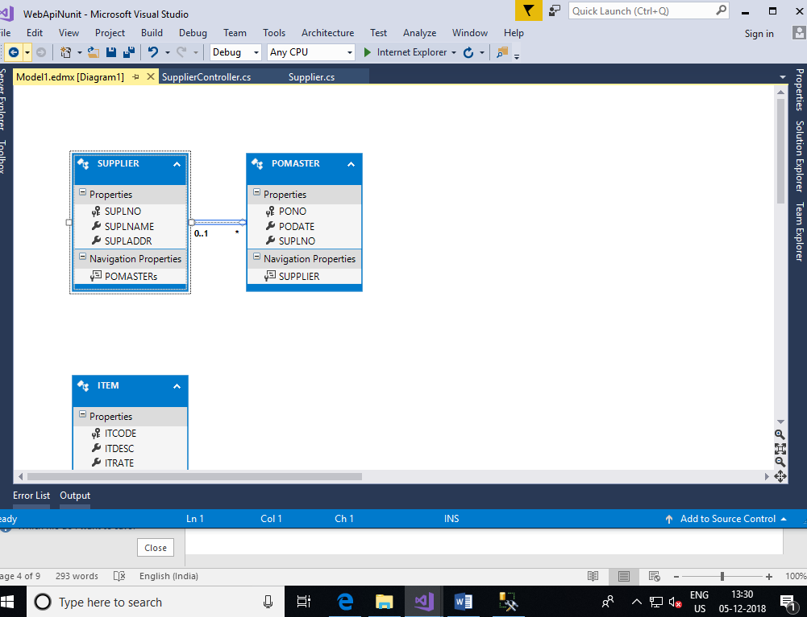

* Write the below code in SupplierController class to get supplier info details.

using System;

using System.Collections.Generic;

using System.Linq;

using System.Net;

using System.Net.Http;

using System.Web.Http;

using WebApiNunit.Models;

namespace WebApiNunit.Controllers

{

public class SupplierController : ApiController

{

public IHttpActionResult GetAllSuppliers()

{

IList<Supplier> suppliers = null;

using (var ctx = new podbEntities())

{

suppliers = ctx.SUPPLIERs.Include("Items")

.Select(s => new Supplier()

{

SuplNo = s.SUPLNO,

SuplName = s.SUPLNAME,

SuplAddr = s.SUPLADDR

}).ToList<Supplier>();

}

if (suppliers.Count == 0)

{

return NotFound();

}

return Ok(suppliers);

}

}

}

* Right-click the WebApiNunit.Tests project and select **Manage NuGet Packages**. You must select the WebApiNunit.Tests project to add the packages to that project

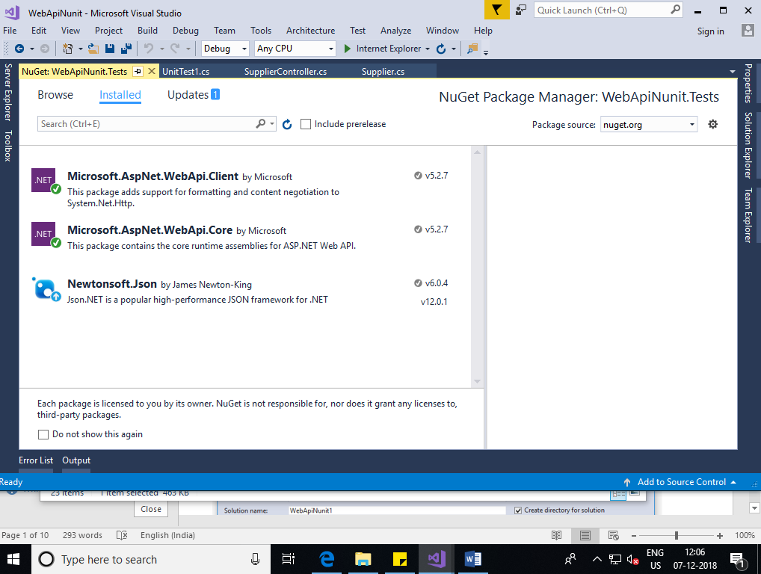

* To Create test write below code in unitTest1.cs

using System;

using Microsoft.VisualStudio.TestTools.UnitTesting;

using WebApiNunit;

using WebApiNunit.Controllers;

using WebApiNunit.Models;

namespace WebApiNunit.Tests

{

[TestClass]

public class UnitTest1

{

[TestMethod]

public void TestMethod1()

{

var controller = new SupplierController();

var testsupplier = controller.GetAllSuppliers();

}

}

}

**Run tests**

All of the method that are marked with the **TestMethod** attribute will be tested. From the **Test** menu item, run the tests.

Open the **Test Explorer** window as below

